NMMU CHESS CLUB
FIRST MEETING MINUTES

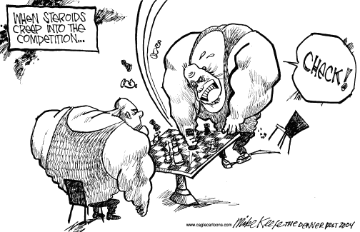

18 APRIL 2012
NORTH TENNIS CLUBHOUSE

CHESS MEETING MUNITES
Date: 12 April 2012
Time: 17:30
Venue: North Campus Tennis Clubhouse
Apologies: None
Confirmation to attendance : Attendance register circulated
Opening: Noxolo Qanqa–addressed the following matters.
a)Drop in members ‘attendance
The main causes that were discussed were :- Time, top strong players do not have a reason to come. Marketing of the club is poor and not being active.
Solution-Fixed blitz tournament, Chess Open day(get date from Zan), Big chessboard outside North Campus(Tamlin find out from a friend doing design).
Tournaments-Once a month in different residences(Noxolo contact the res manager)
b) USSA Closed
The University will cover these costs ,Lebo and Tamlin to confirm with Zanele.
c) NMMU Chess Club invitational Tournament
Proposed date second week of July (with prize money) for proper
Planning, Lebo will have to check dates on the EP Calendar and Chessa websites for clashes with other big tournaments.
d) Committee Members ‘Duties-Lebo will run the Monday’s coaching and delegate his duties to the rest of the committee members and do a follow up. Jonel do a follow up on the IT department regarding sponsorship .Tinus suggested members to pop by EP trials to inform parents about The NMMU Chess Club.

e)USSA Open tournament
Each member to do a list of things that went wrong and right at USSA last year. It was to be decided on whether to organise the tournament by the committee members or NMMUs event office also a sponsor would be favourable.
LOC-should be appointed and Sven to be made TD.
Duties for each member were as follows:-
Lebo-In charge of LOC-lead and ensure that members do their duties.
Noxolo-Clocks, boards and equipment
Jonel-Funding and Administration Communication assist Zan.
Lonwabo – Directions(where to get what) and registration day.
Tamlin- Organise the social dinner(Wednesday)and the Final Dinner
Boardwalk free movie night and Tourism pack(Noxolo assist) with events.
Tinus suggested bringing GM Pablo for a seminar or a simultaneous and that Fiona Burgers will be available to help and Lonwabo ‘s kids can help.
Constitution for meeting minutes
Next Meeting Agenda-based on open day date from Zan
-Invitational Tournament
-USSA Open
-Ground Prix and Blitz(Jonel)
-Big Chess Tournament
Meeting was adjourned by Noxolo at 19:30

