NMMU CHESS CLUB
FIRST MEETING MINUTES

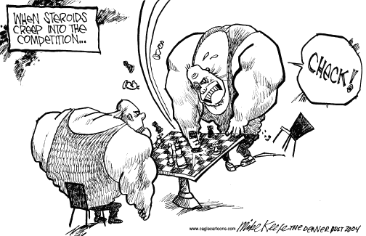

07 MARCH 2012
NORTH TENNIS CLUBHOUSE

CHESS MEETING MUNITES
Date: 07 March 2012
Time: 17:00
Venue: North Campus Tennis Clubhouse
Apologies: None
Confirmation to attendance : No attendance register circulated
Opening: Zanele Mdodana –introducing herself to new members as NMMU Chess Club Manager and addressed the following matters.
a)Membership
All members must fill in the membership forms even old members from last year.
b) Tournament Feedback
Any tournament participation by the Club members should be documented and reported back to the Zanele i.e. Tournament Results ,challenges , achievements etc .etc.
c) NMMU Chess Club invitational Tournament
Tournament was to be held on the 9th and 10th of March 2012,but was postponed due to lack of players until further notice.
d) NMMU Chess Club Website and Face book page
Jonel Vorster (Captain) will be responsible for the website updates and newsletters and Lebohung Ramollo(Chairperson) will take over the facebook page.
e) Campus residence league
This was one of the reasons that the budget of the club was cut, because it had no form of league . The Friday coaching sessions for beginners can be used as a campus res league. Outreach programme is also essential for the club to generate points in its favour.
f) Committee decision making
The committee must sit down and write a proposal on a matter(Club needs and ideas)and notify the Zanele at least a week in advance for convenience purposes. Quires regarding the club i.e. budget ,maintenance, complaints must sent to the Zanele.
QUESTIONS FROM MEMBERS
Lonwabo:
“What is the criteria to be a bursary holder?”
Zanele:” National Representative, provincial Rep and number one in the Chess Club, Bursary amount is R12000”
-As form of outreach Lonwabo informed the club members about the Motherwell ‘s monthly tournaments and this month’s tournament will be 30th March 2012 ,members should participate to raise funds for the Motherwell Chess Club.
-Secondly Lonwabo suggested that this year’s NMMU Chess Open Tournament should be held in the Mother well Sport Centre, to introduce Chess to the Mother well Community.
It was decided that the idea should not be used because of the long distance and it will be inconvenient to most prospective players. The NMMU Mission vale Campus is the proposed new venue.
Tamlin:
‘’When will the USSA Closed take place and the cost”
Noxolo Qanqa (secretary): Nothing has been confirmed yet.
Lebohung:
Informed the members about the Queen Indian Defence Fixed Opening Tournament on Mondays ,starting on the 12 March 2012 ,and that the will be a split whereby Monday’s Practice is for beginners and Wednesdays for more advance players. Also requested Noxolo to distribute the Susan Polgar’s Manual to the players, also 6 more digital clocks to be bought and Club championships and Zanele informed the club that the costs will be taken out from the Chess Club’s budget.
Tinus
Informed the members about the P.E Chess Club games on Thursday nights and encourage players to participate.
Next meeting: No date was set
No more matters were discussed the meeting was adjourned by Zanele at 18:00.

.

